**NAAN MUDHALVAN-IBM(AI) PROJECT** IBM AL 101 ARTIFICIAL INTELLIGENCE-GROUP 1(TEAM 5)

**PROJECT TITLE:**

CREATE A CHATBOT USING PYTHON

**TEAM MEMBERS:**

Banu Priya S (Reg.No.110321121005)

Jeevitha B (Reg.No.110321121013)

Vinodhini V (Reg.No.110321121047)

Kalai Priya S G (Reg.No.110321121016)

Sandhiya S (Reg.No.110321121033)

**Phase 2: Innovation**

**Innovative Design for Creating a Python Chatbot** Designing a chatbot using Python can

be innovative and effective by incorporating cutting-edge technologies and creative problem-solving. Let's explore innovative design elements to solve common problems and make your chatbot stand out:

1. Advanced Natural Language Processing (NLP)

2. Multimodal Interaction

3. Emotion Recognition

4. Personalization

5. Contextual Understanding

6. Predictive Typing

7. IoT Integration

8. Multilingual Support

9. Voice Synthesis

10. Continuous Learning

11. Voice Biometrics

12. Augmented Reality (AR) Integration

13. Blockchain for Data Security

14. Quantum Computing for Speed

15. Ethical AI

16. AI Chatbot Marketplaces

**1.Advanced Natural Language Processing (NLP):**

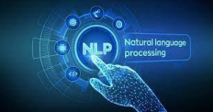

Utilize state-of-the-art NLP models like GPT-3 or BERT to enable your chatbot to understand and generate human-like responses with context and coherence.

**2.Multimodal Interaction:**

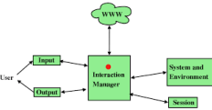

Innovate by allowing the chatbot to process text, images, voice, and even gestures. This expands its capabilities to assist users with a wide range of queries and interaction modes.

**3.Emotion Recognition:**



Implement sentiment analysis and emotion

recognition algorithms to gauge the user's emotional state based on text input or voice tone. The chatbot can adapt its responses to provide empathy or assistance accordingly.

**4.Personalization:**

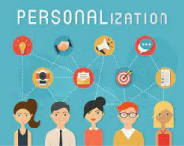

Use machine learning to personalize the

chatbot's responses based on user behavior, preferences, and historical interactions. Consider recommending products, content, or services tailored to individual users.

**5.Contextual Understanding:**

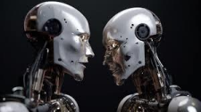

Enhance the chatbot's contextual awareness

by storing and recalling previous interactions. This enables more meaningful and coherent conversations over time, making users feel understood.

**6. Predictive Typing:**

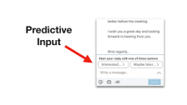

Implement predictive typing suggestions using machine learning models.  This feature can assist users in formulating queries faster and with greater accuracy, improving user experience.

**7.IoT Integration:**

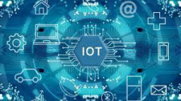

Extend the chatbot's functionality by enabling it to

control and interact with Internet of Things (IoT) devices, such as smart home appliances, through voice or text commands.

**8.Multilingual Support:**

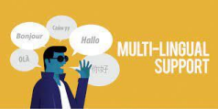

Make your chatbot multilingual to cater to a  global audience. Implement language detection and translation features to facilitate seamless communication in different languages.

**9.Voice Synthesis:**

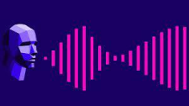

Develop a natural-sounding voice for your chatbot using text to-speech (TTS) synthesis, enhancing the quality of voice interactions and user engagement.

**10.Continuous Learning:**

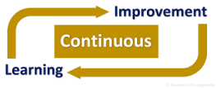

Implement reinforcement learning algorithms to

allow your chatbot to learn and improve its responses over time based on user feedback and interactions.

**11.Voice Biometrics:**

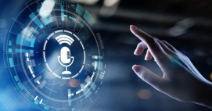

Enhance security by incorporating voice biometric

authentication for sensitive interactions, such as account access or transactions.

**12.Augmented Reality (AR) Integration:**

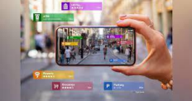

For mobile chatbots, consider integrating AR features

to provide visual assistance, such as overlaying instructions on a user's camera feed.

**13.Blockchain for Data Security:**



Explore blockchain technology to ensure the security

and integrity of user data and chatbot interactions, instilling trust in users.

**14. Quantum Computing for Speed:**

In the future, consider harnessing the power of

quantum computing to make real-time processing and decision-making even faster and more efficient.

**15. Ethical AI:**

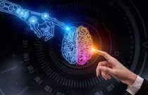

Ensure that your chatbot adheres to ethical AI

principles, respects user privacy, and follows responsible AI practices to gain user trust and compliance with regulations.

**16.AI Chatbot Marketplaces:**

Create a marketplace where users can enhance

their chatbot with AI plugins, allowing for greater customization and functionality, fostering a community of innovation.

By integrating these detailed innovative elements into

your Python chatbot design, you can create a solution that not only addresses specific problems but also offers a truly exceptional user experience.

**BLOCKS OF CHATBOT**

Chatbots are built using various components or blocks that work together to enable communication between the bot and users. These blocks can vary in complexity depending on the specific requirements and capabilities of the chatbot, but here are some common components:

**User Interface (UI):** The user interface is how users interact with the chatbot. This can be a chat window on a website, a messaging app, or a voice interface in a smart device.

**Natural Language Processing (NLP):** NLP is a crucial component that enables the chatbot to understand and process natural language inputs from users. NLP involves tasks like text tokenization, entity recognition, sentiment analysis, and language understanding.

**Dialog Management:** Dialog management handles the flow of the conversation. It determines how the chatbot responds to user inputs and manages context and conversation history. Dialog management can be rule-based, state-machine-based, or based on machine learning models.

**Knowledge Base**: Some chatbots rely on a knowledge base to provide information to users. This knowledge base can be a structured database or unstructured text documents. The chatbot accesses this information to answer user queries.

**Machine Learning Models**: Machine learning models, such as deep learning models, can be used to improve the chatbot's language understanding, generate responses, and make predictions. Common models include Recurrent Neural Networks (RNNs) and Transformers.

**Intent Recognition:** Intent recognition is a subset of NLP that determines the user's intent or goal behind a message. It helps the chatbot understand what the user wants and respond accordingly.

**Entity Recognition:** Entity recognition identifies specific pieces of information within user input, such as names, dates, locations, or product names. This is crucial for handling requests that involve structured data.

**Response Generation:** Once the chatbot understands the user's intent and extracts relevant information, it generates a response. This can be done using pre-defined templates, rule-based systems, or more advanced natural language generation techniques.

**API Integration:** Chatbots often need to interact with external systems or services to fulfill user requests. Integration with APIs allows the chatbot to perform actions like making reservations, retrieving weather information, or accessing user accounts.

**User Authentication and Authorization:**

If the chatbot interacts with user accounts or sensitive data, it needs mechanisms for user authentication and authorization to ensure security and privacy.

**Testing and Training:** Continuous testing and training are essential for chatbots to improve over time. Testing helps identify issues, while training involves updating models and data to enhance performance.

**Analytics and Monitoring:** Analytics tools are used to track the chatbot's performance, including user engagement, error rates, and frequently asked questions. Monitoring ensures the chatbot is functioning correctly and can trigger alerts for issues.

**Deployment and Hosting:** Once the chatbot is developed, it needs to be deployed on a server or cloud platform to make it accessible to users. This involves hosting and infrastructure considerations.

**User Feedback Mechanisms:**

Collecting feedback from users is valuable for improving the chatbot. Feedback mechanisms can include surveys, rating systems, or direct user input.

**Maintenance and Updates**:

Chatbots require ongoing maintenance to address issues, update knowledge, and improve performance. Updates may involve adding new features or improving existing ones.

These are some of the fundamental blocks that make up a chatbot system. The specific components and their complexity can vary depending on the chatbot's purpose, complexity, and the technologies used in its development.

**BLOCK DIAGRAM**

A chatbot block diagram illustrates the various components and their interactions within a chatbot system. Below is a simplified block diagram of a chatbot:

Here's a brief description of each block:

+--------------------------------------+

| User Interface |

+--------------------------------------+

| (User Input)

|

v

+--------------------------------------+

| Natural Language Processing |

+--------------------------------------+

| (Extracted Text)

|

v

+--------------------------------------+

| Intent Recognition & |

| Entity Recognition |

+--------------------------------------+

| (Intent, Entities)

|

v

+--------------------------------------+

| Dialog Management |

+--------------------------------------+

| (Context, State)

|

v

+--------------------------------------+

| Knowledge Base / |

| External APIs |

+--------------------------------------+

| (Information)

|

v

+--------------------------------------+

| Response Generation |

+--------------------------------------+

| (Generated Response)

|

v

+--------------------------------------+

| User Interface |

+--------------------------------------+

| (Bot Response)

|

v

+--------------------------------------+

**User Interface:** This is where users interact with the chatbot, sending messages or voice input.

**Natural Language Processing (NLP):** NLP processes the user's input, including tokenization, sentiment analysis, and language understanding.

**Intent Recognition & Entity Recognition**: These components determine the user's intent and extract entities from the input.

**Dialog Management:** Dialog management handles the conversation flow, maintains context, and decides how the chatbot should respond.

**Knowledge Base / External APIs**: The chatbot may access a knowledge base or external services to retrieve information needed for responses.

**Response Generation**: This block generates a response based on the recognized intent, extracted entities, and the chatbot's knowledge.

**User Interface**: The final response is presented to the user through the same user interface.

Note: This is a simplified representation, and real-world chatbot architectures can be more complex, with additional components for authentication, analytics, and more. Additionally, the implementation details within each block can vary based on the chatbot's design and requirements.

**CONCLUSION**

A chatbot is one of the simple ways to transport data from a computer without having to think for proper keywords to look up in a search or browse several web pages to collect information; users can easily type their query in natural language and retrieve information.